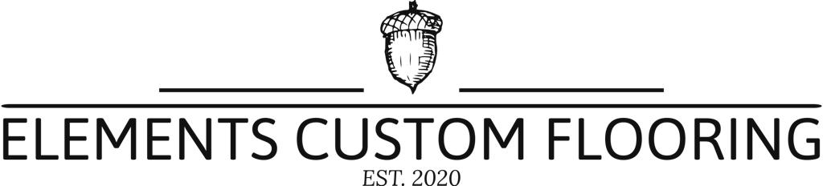

Let's talk about SPC flooring sustainability and it’s advantages

**1. Green and environmental protection**

Today is an era of pursuing sustainable development. New materials and new energy are emerging in an endless stream. **SPC Floor** is the only recyclable floor decoration material, which is of great significance for protecting our earth's natural resources and ecological environment. SPC floor is a new type of environmentally friendly floor developed based on high technology. It has the characteristics of **ZERO formaldehyde**, **mildew proof, moisture proof, fire proof, insect proof, and simple installation.** SPC flooring is very popular in developed countries in Europe and America and the Asia-Pacific market. With its excellent stability and durability, it not only solves the problem of damp, deformed and moldy solid wood flooring, but also solves the environmental protection problems of other decoration materials such as **formaldehyde**, which is in line with domestic high-end customers requirements for use. The future has come, and many indoor places such as offices, hotels, commerce, homes, etc. have already selected SPC lock flooring as their choice of sustainable development.

SPC flooring is one of the major categories of PVC flooring. When thinking of PVC flooring, more people think of plastic. Many people also confuse **PVC flooring with PVC pipes.** Plastics contain **toxic** substances and are harmful to the human body. But SPC floor and plastic are **NOT** the same at all. SPC floor does not need glue during the production process, does not contain **toxic** substances such as **formaldehyde** and **benzene**, and has **NO** **radiation**. It is a green decoration material and will not cause harm to the human body. SPC floor is an economical floor material. At present SPC flooring is the only decorative flooring that can be recycled. This is obviously of great significance to protect our planets natural resources and ecological environment. Consumers can enjoy the texture of wood grain or stone grain during use without being bothered by noise. According to consumers' requirements for sound insulation, they can choose blocks, plates or coils. While possessing technical performance and design sense, we produce environmentally friendly products and pay attention to the health of users.

The main raw material of SPC floor is **polyvinyl chloride**. Polyvinyl chloride is an environmentally friendly, non-toxic and renewable resource. It has been widely used in people's daily life, such as tableware, medical infusion tube bags, etc., and its environmental protection is no need to worry . The main components of **Indoor SPC Floor** are **virgin PVC and natural limestone powder**, which does not contain any radioactive elements after testing by the national authority. It is a new type of green and environmentally friendly floor decoration material. Any qualified SPC needs to pass **IS09000** international quality system certification and **ISO14001** international green environmental certification.

At present, the consumer concept of customers in the market is shifting to qualitative consumption. The domestic SPC floor home improvement industry is growing rapidly every year. With the promotion of urbanization, the future decorative building materials market will be prosperous, and at the same time, a new generation of consumers will emerge. , Young and energetic consumers will be more inclined to environmental protection, beautiful and economical design concepts. Therefore, SPC floor home decoration will be more popular than other floors such as solid wood floor and stone floor on the market because of its excellent performance.

**2. Super wear-resistant**

The surface of the SPC floor has a special transparent wear-resistant layer processed by high-tech, and its wear-resistant revolution can reach more than 8000 revolutions. Among the traditional floor materials, the more wear-resistant laminate flooring has a wear-resistant revolution of only 800-4000 revolutions. The wear-resistant layer on the surface of the SPC floor can be used for 5-10 years under normal conditions depending on the thickness. Therefore, in hospitals, schools, office buildings, shopping malls, supermarkets, vehicles and other places with large traffic, SPC floors are becoming more and more popular.

**3. High elasticity and super impact resistance**

The texture of SPC floor is softer and elastic, and it has good elastic recovery under the impact of heavy objects. The texture of coiled floor is softer and more elastic, and its comfortable foot feel is called "soft gold on the floor. At the same time, the SPC floor has strong impact resistance, and has strong elastic recovery for heavy impact damage without causing damage. The excellent SPC floor can minimize the damage of the ground to the human body, and can disperse the impact on the feet. The latest research data shows that after an excellent SPC floor is installed in a space with a large flow of people, the rate of falls and injuries is reduced by nearly 70% compared with other floors.

**4. Super anti-skid**

The wear-resistant layer of the SPC floor has special anti-slip properties, and compared with ordinary floor materials, the floor feels more astringent when it is wet, and it is less likely to fall, that is, the more water it is, the more astringent it is. Therefore, in public places with high public safety requirements, such as airports, hospitals, kindergartens, schools, etc., they are the first choice for ground decoration materials. It has become very popular in China in recent years.

**5. Heat conduction to keep warm**

SPC floor has high quality and stable material physical properties. Good thermal conductivity, uniform heat dissipation, and will not swell and deform when used for home decoration floor heating. Flooring in Europe, America, Japan, South Korea and other countries and regions, is the first choice for home improvement floor heating and thermal conductive flooring.

**6. Convenient maintenance**

The maintenance of SPC floor is very convenient. If the floor is dirty, wipe it with a mop. If you want to keep the floor lasting bright, you only need to wax it regularly, and the maintenance frequency is much lower than other floors.

**7. International Popularity**

SPC floor is a new type of floor decoration material widely used in countries all over the world today. It is very popular in the European and American markets and the Asia-Pacific market. It is also very popular in China, and its development prospects are very broad.

The company not only provides SPC flooring, but also [**Laminate Engineered Wood Flooring**](https://www.hometopflooring.com/laminate-flooring/). Please feel free to contact us if you need it.